Name: RAJESHWAR RAO THAKKALLAPALLY

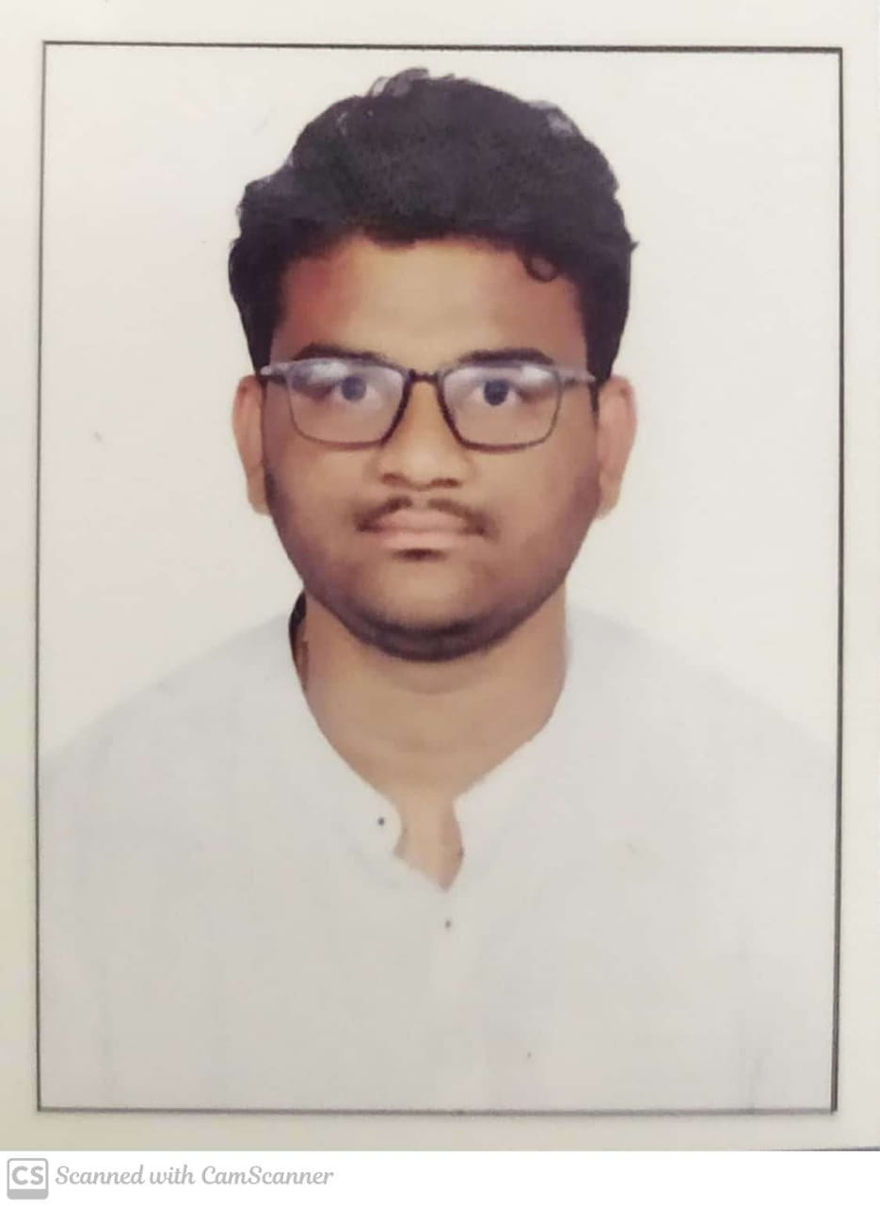

E-Mail: rajeshwarrao1256@gmail.com

Contact No: +919963323938

Address: H No:2-112/1, Bethigal, Veenavenka,

Karimnagar,Telangana.

# Career Objective

To work with an organization or company which offers challenging opportunities, an excellent cooperative working environment, enabling me to improve my abilities, develop my functionality, and improve the organization plans and work procedures.

|  |  |  |  |
| --- | --- | --- | --- |
| **Academic Details** | | | |
| **Course of Study** | **Name of the Institute** | **Duration of the Course** | **Aggregate** |
| **B.Tech - Branch** | VNR Vignana Jyothi Institute of Engineering and Technology (Information Technology) | 2018-Present | 9.30 |
| **INTERMEDIATE/ 10+2** | Narayana Junior College | 2016-2018 | 9.87 |
| **X CLASS/ SSC** | Tejaswi High School | 2016 | 10 |

# Technical Skills

* Data Structures and Algorithms
* SQL
* AWS

**Programming Languages**

* CPP
* Python
* Java

# Certifications / Courses Undertaken:

* Python – Certificate by A.V.R. Technosoft Solutions Private Limited
* Smart Interviews (DSA)
* Machine Learning with python offered by IBM
* AWS from 360DigiTMG

# Project Works:

**Title**: **BLOOD BOON**

**Technologies Used**: MERN Stack

**Description**: Search for blood donors by acceptors in search engine, Interface for acceptors to know the details about the donor, Search for blood group in the blood banks will be available

**Title**: **HOSPITAL MANAGEMENT SYSTEM**

**Technologies Used**: Node JS, Mongo DB, Express, EJS, CSS, Bootstrap

**Description**: Hospital Management system includes registration of patients, storing their disease details into the system. It will also contain doctor’s information and availability of a doctor.

# Co-curricular Activities

* Head of CODING CLUB ACM VNRVJIET. We as a group conduct sessions on DSA and Competitive Coding.
* Volunteer in ACM Student chapter

**Achievements**

* Won first price in J-HUB Hackathon conducted in state Level
* Selected for central level hackathon (SIH)

# Declaration:

To the best of my knowledge the above statements are true and I understand that withholding or misstating any fact may result in the refusal for placement.

Place: Hyderabad

(Rajeshwar Rao)